Student worksheet

3.1 Water can change state

Pages 48–49 and 184

The state we’re in

1 Complete the flow chart below to revise your understanding of the states of water.

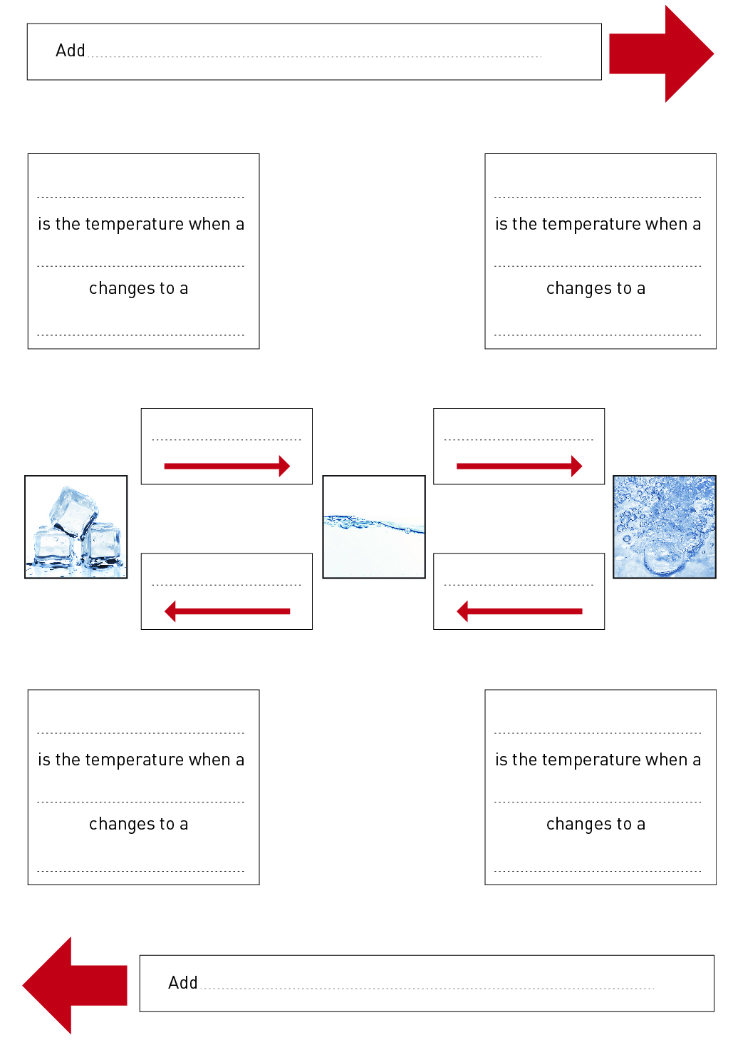

2 After completing the ‘Three States of Water’ experiment, label the diagram below to identify the processes causing the changes of state.

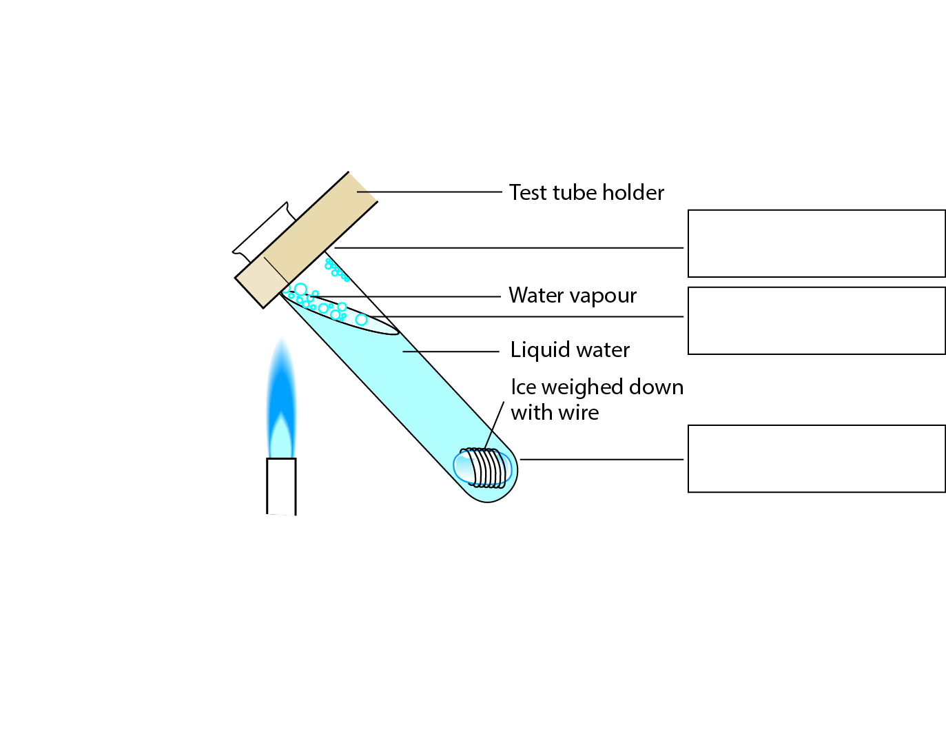

3 Below are a series of change of state equations. Fill in the state in the space provided.

a ice + heat = ______________________________________________________

b water – heat = ______________________________________________________

c steam – heat = ______________________________________________________

d water + heat = ______________________________________________________

4 Below are a series of change of state sentences. Fill in the process that leads to the change of state in the space provided.

a When you add heat to ice, the process that causes a change of state is known as:

b When you add heat to water, the process that causes a change of state is known as:

c When you remove heat from water, the process that causes a change of state is known as:

d When you remove heat from steam the process that causes a change of state is known as:

EXTEND YOUR UNDERSTANDING

5 A new state of mater called the Bose–Einstein condensate was predicted in the 1920s and proved in the 1990s. Find out what the Bode–Einstein condensate is and whether water can be in this state.

Student worksheet

3.2 Water cycles through the environment

Pages 50–51 and 185

Riding with H2O – the water cycle

1 Complete the flow chart below to revise your understanding of the water cycle.

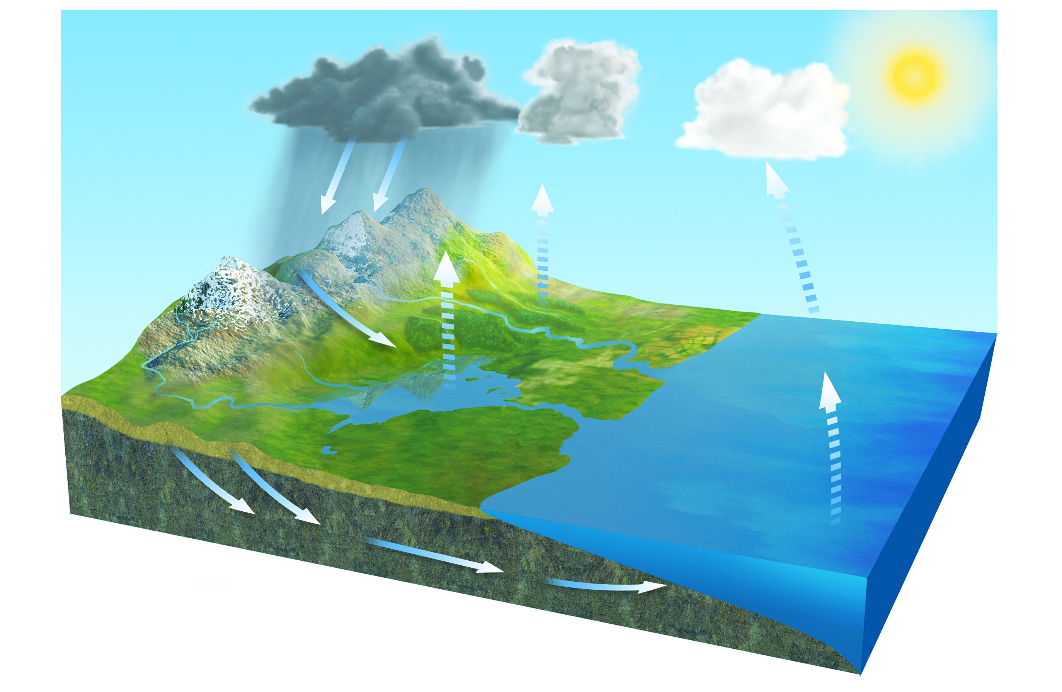

2 What is the role of the Sun in the water cycle?

3 Think about the different processes that lead to changes of state during the water cycle. Fill in the process and the state in the spaces below:

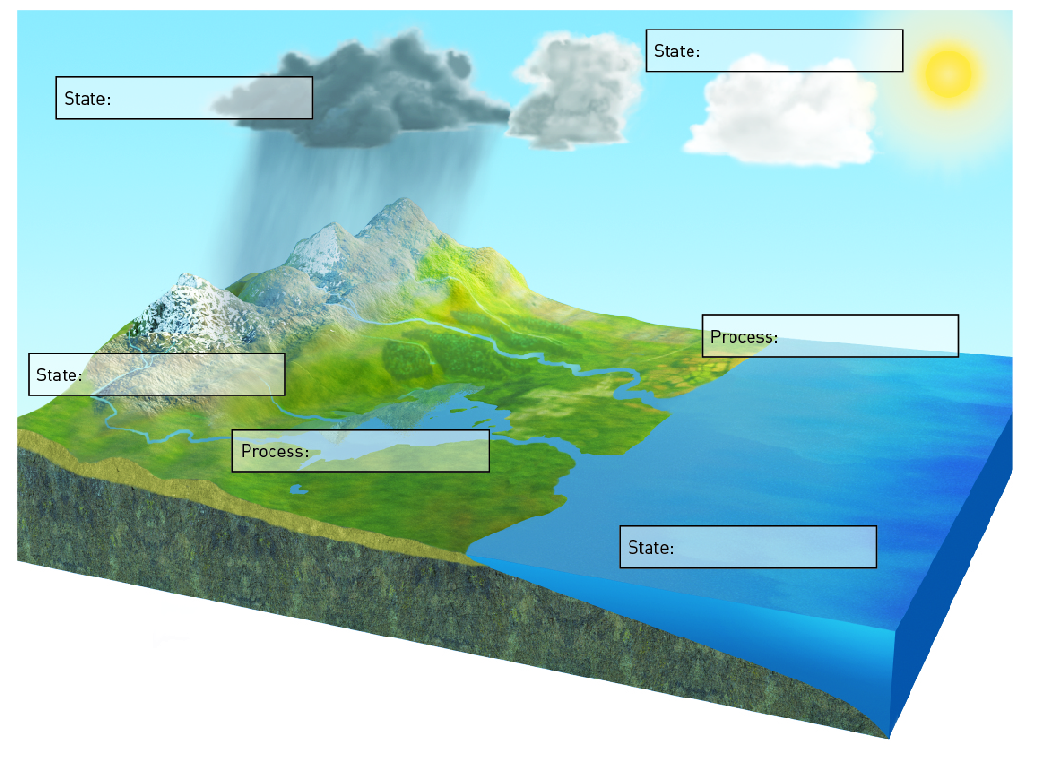

EXTEND YOUR UNDERSTANDING

4 Humans take in and excrete water in their contribution to the water cycle. Research the movement of water into and out of the human body through these three systems:

• Respiratory (breathing)

• Urinary (urinating)

• Integumentary (sweating)

Student worksheet

3.3 Factors in nature affect the water cycle

Pages 52–53

Land of droughts and flooding rains

1 The diagram below shows the processes of El Niño. Fill in the correct boxes with the following information: the process during El Niño or the water cycle or the state of matter.

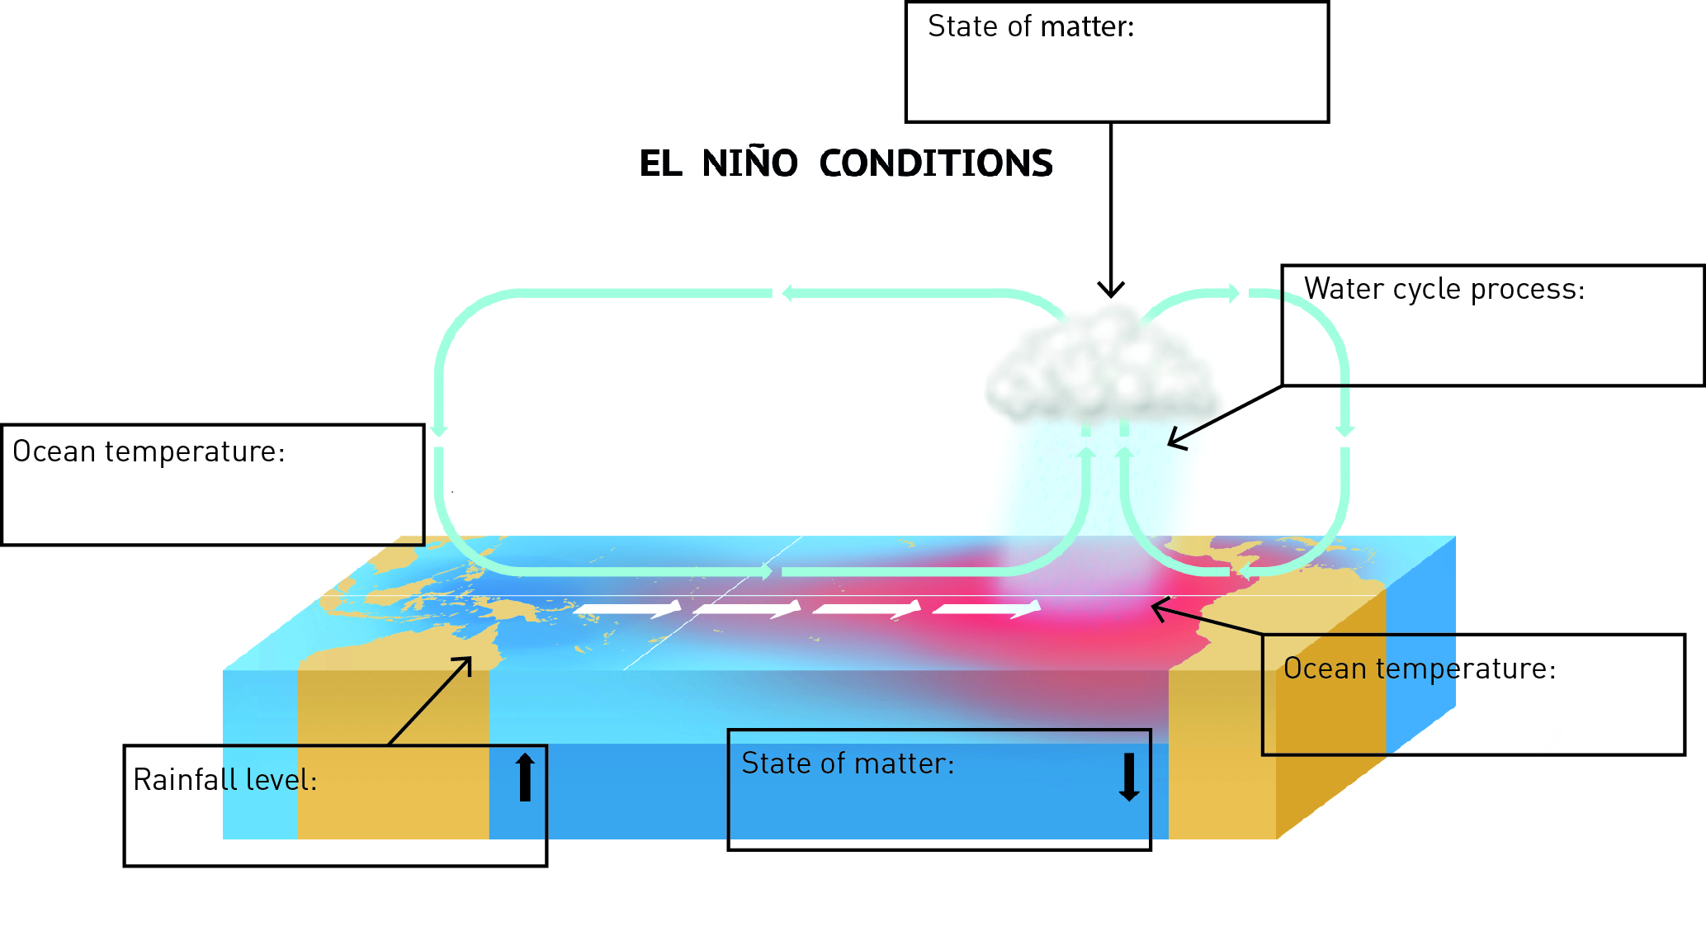

2 Describe how El Niño affects Peru.

3 Describe how La Niña affects Peru.

4 The diagram below shows the processes of La Niña. Fill in the correct boxes with the following information: the process during La Niña or the water cycle or the state of matter.

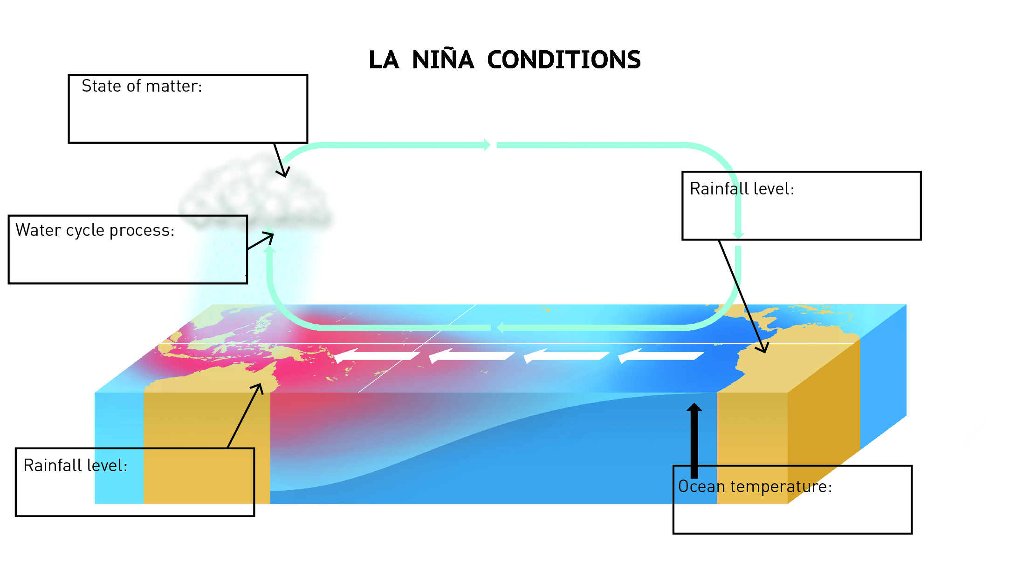

EXTEND YOUR UNDERSTADNING

5 The Australian government’s Bureau of Meteorology can predict El Niño and La Niña events by using the ENSO tracker. Using the Bureau of Meteorology’s website (http://www.bom.gov.au/climate/enso/tracker), research the following questions:

a What is the ENSO tracker?

b What are the criteria used to determine whether an El Niño event is occurring?

c What are the criteria used to determine whether a La Niña event is occurring?

d Observe the ‘recent ENSO values’ graph for the years from 1980 to the present year. How many El Niño events and how many La Niña events occurred in this period?

e Is Australia likely to encounter El Niño or La Niña over the next 12 months?

Student worksheet

3.4 Human management affects the water cycle

Pages 54–55 and 186

What’s the use of water?

1 Approximately 65% of the water we use in Australia is used for agricultural purposes.

a What part of the water cycle provides water for agriculture without the use of irrigation?

b What are three sources of water for irrigation?

c In the table below, write three pros and three cons of using water for agriculture.

|  |  |
| --- | --- |
| PROS of using water for agriculture | CONS of using water for agriculture |
|  |  |
|  |  |
|  |  |

2 Industry has a major effect on the water cycle through the emission of pollution due to the burning of fossil fuels. If pollution from burning fossil fuels mixes with water vapour in the clouds, how could this affect humans?

3 The Thomson Dam and the Warragamba Dam are marked on map below.

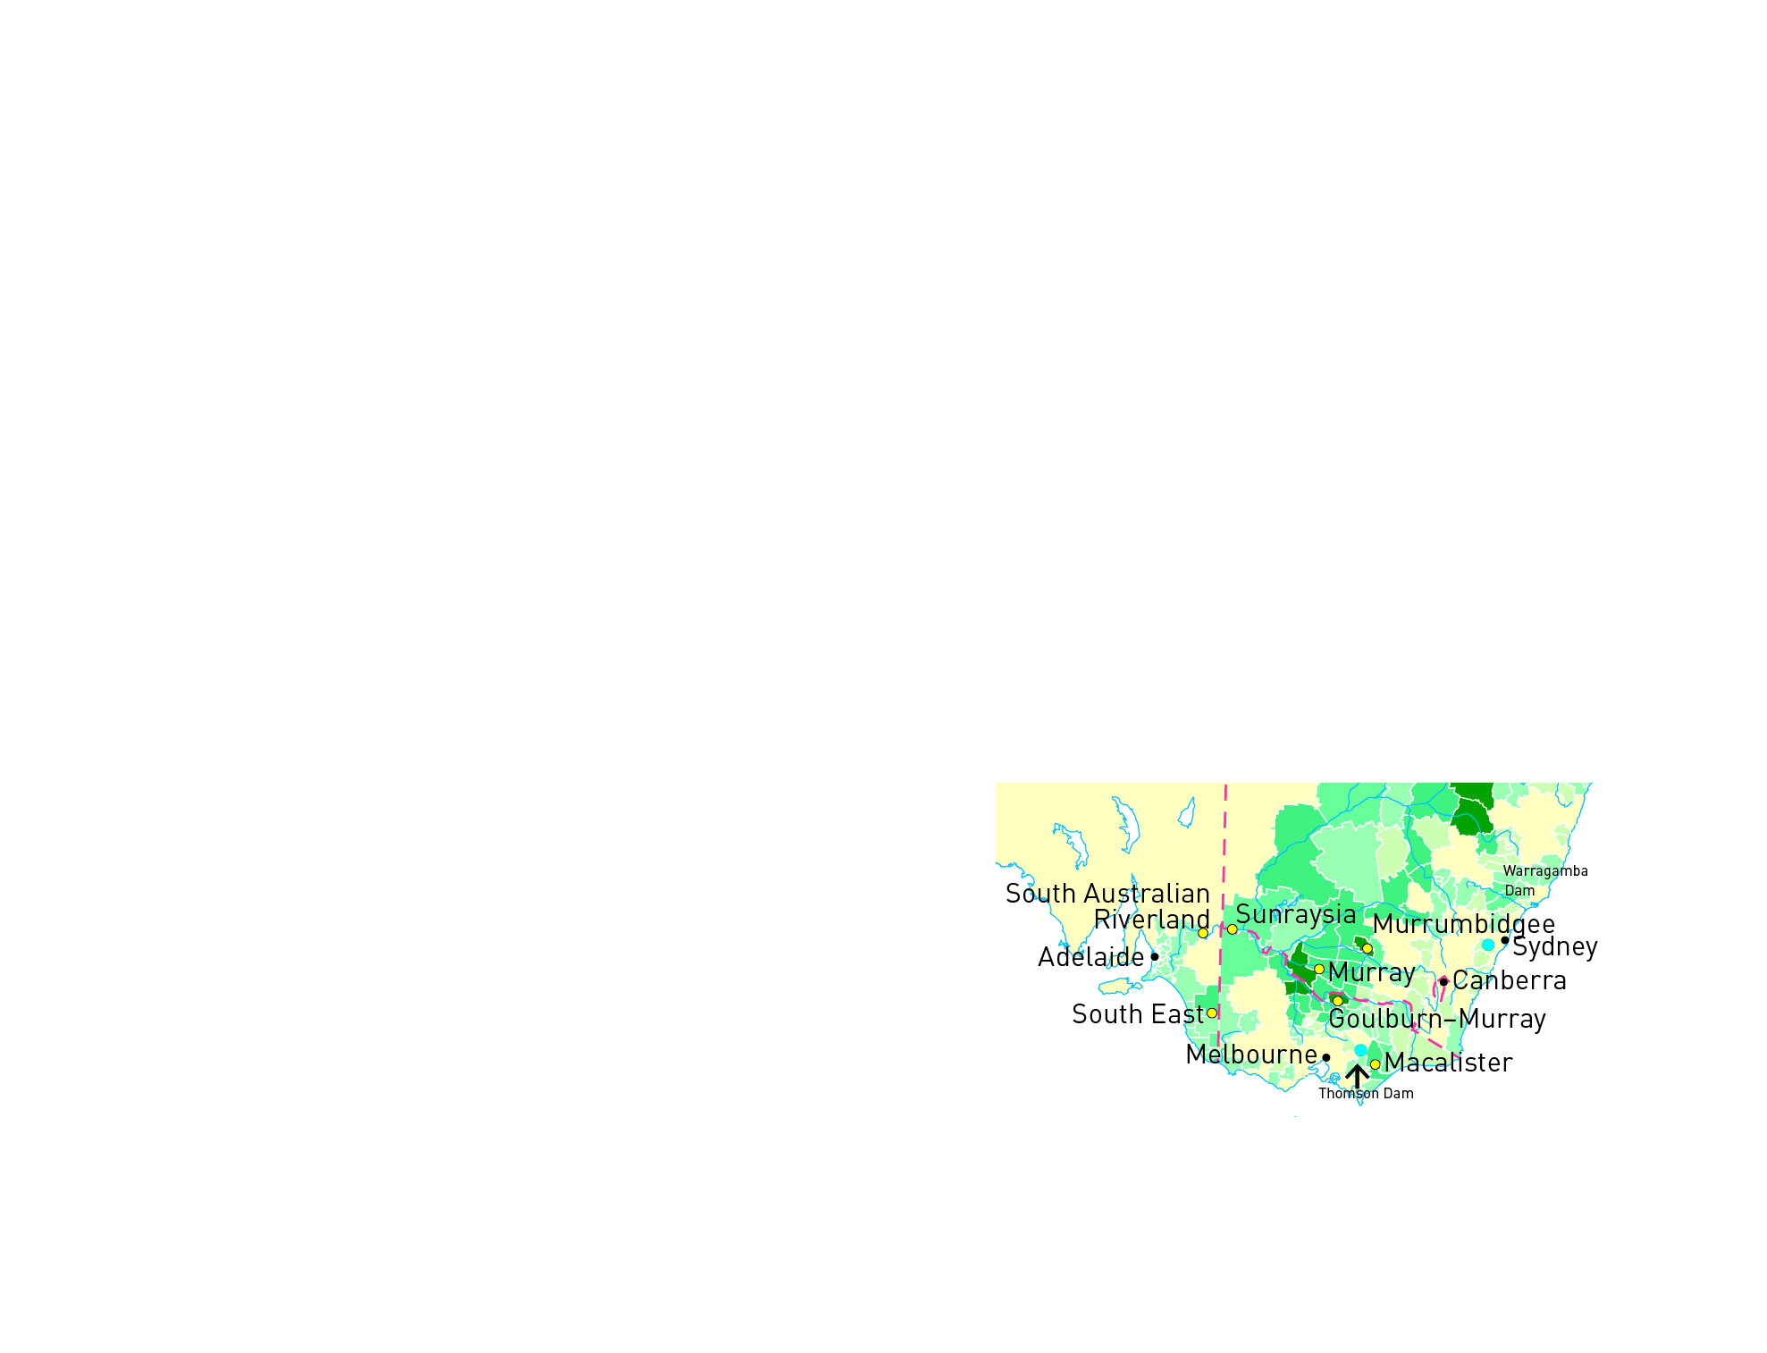

a Which city would use the Thomson Dam for part of its domestic water supply?

b Which city would use the Warragamba Dam for part of its domestic water supply?

c How might agriculture use the water from the two dams?

EXTEND YOUR UNDERSTANDING

4 Research the Wonthaggi Desalination plant in Victoria. Discover why it was built and explain how this is linked to human impact on the water cycle.

Student worksheet

3.5 Science as a human endeavour: Water is a precious resource

Pages 56–57

There’s precious little water

1 If the world’s water was represented by a 1 litre (1000 millilitre) container, try to calculate the number of millilitres for the following categories:

a Salt water

b Fresh water

c i Fresh water in ice caps and glaciers

ii Fresh water in ground water and soil

iii Fresh water in lakes and rivers

2 The amount of water available per person on Earth is estimated to be 222 billion litres. Using Figure 3.19 in the textbook as a guide, complete the table below.

|  |  |  |
| --- | --- | --- |
| Location of water | Amount of water available per person (litres) | % Total water |
| Total water on Earth | 222 billion | 100 |
| Fresh water on Earth |  | 2.5 |
| Liquid (not frozen) fresh water on Earth |  | 0.75 |
| Fresh water in lakes and rivers |  | 0.025 |

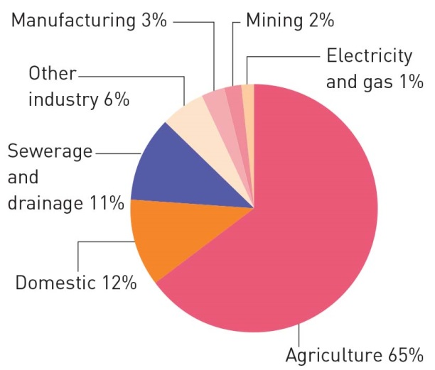3 The amount of water available per person is an enormous amount, but not when you consider the chart below (keeping in mind this shows water use in Australia only). Does this figure tell the true story of the water available per person for their own use?

EXTEND YOUR UNDERSTANDING

4 How many litres of water do you think you personally use (drink, flush, wash) each day? Compare your response with that of a classmate or family member.